Request Course Section Pre-Requisite Override

Quick Search: Request Course Section Pre-requisite Override

STEP 1
Select the Academics worklet located in the Applications section on your Workday homepage.
The graphic you would see in Workday appears immediately below this step.
The graphic you would see in Workday appears immediately below this step.

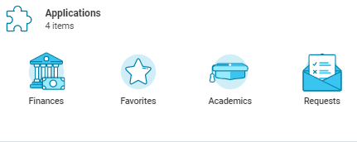

STEP 2
Select Request Course Section Pre-Requisite Override located in the Planning & Registration section.
Note: Select More to expand Planning & Registration section.
The graphic you would see in Workday appears immediately below this step
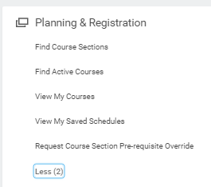

STEP 3
Select Start Date within – Choose Period and then Semester
Select Course – Type in Course Subject and Course Number
Select Course Section – Dropdown will present application Course Sections

Note: Select the fields for the course you want to take without having completed the pre-requisite(s). If a field does not produce drop down options, enter a course or course section ID. If a field still returns “No Items” after submitting your entry, there is either no pre-requisite(s) or the course and course section is unavailable in the selected academic period.
The graphic you would see in Workday appears immediately below this step.
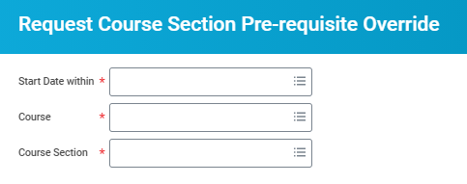

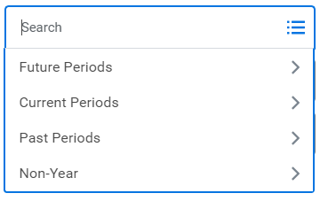

STEP 4
Select OK
The graphic you would see in Workday appears immediately below this step.

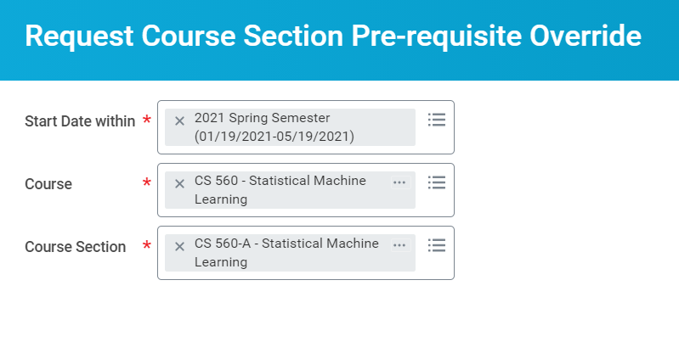

STEP 5
Select Submit
The graphic you would see in Workday appears immediately below this step.

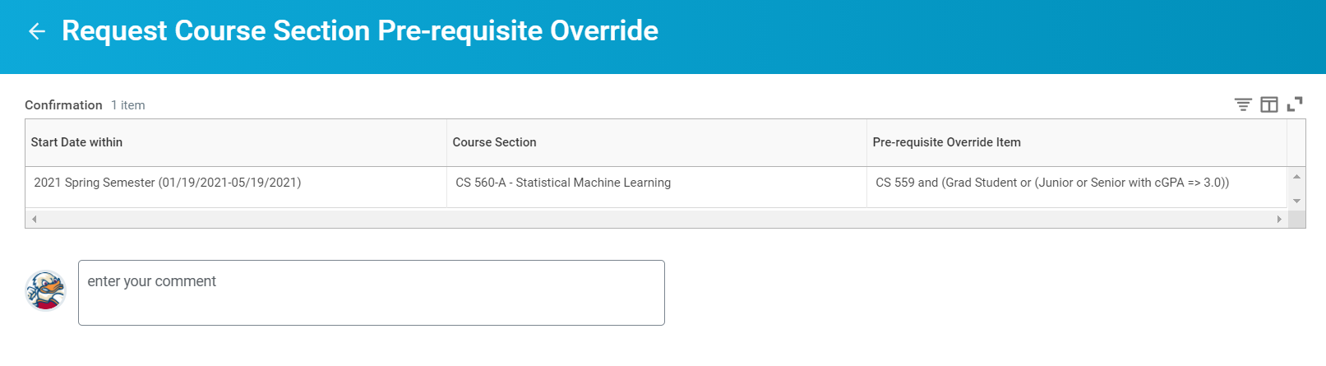

STEP 6
Select Complete Questionnaire
The graphic you would see in Workday appears immediately below this step.
The graphic you would see in Workday appears immediately below this step.
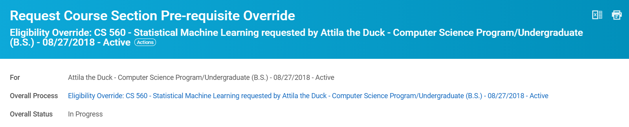

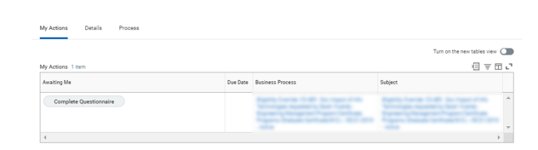

STEP 7
Fill out required field and provide any details necessary.
The graphic you would see in Workday appears immediately below this step
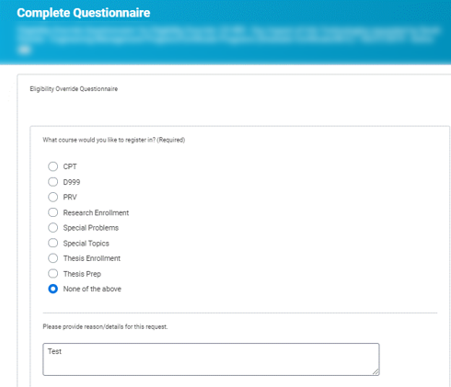

STEP 8
Select Submit
The graphic you would see in Workday appears immediately below

STEP 9
Select View Details
The graphic you would see in Workday appears immediately below this step
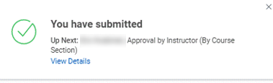

STEP 10
Select the down arrow to expand Details and Process. Select Done
The graphic you would see in Workday appears immediately below this step
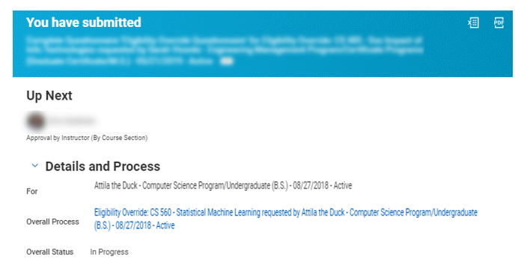

mediately be

